Project- 1: Deploying a Multi-Tier Website Using AWS EC2

Description: Amazon Elastic Compute Cloud (Amazon EC2) provides scalable computing capacity in the Amazon Web Services (AWS) cloud. Using Amazon EC2 eliminates your need to invest in hardware up front so you can develop and deploy applications faster. You can use Amazon EC2 to launch as many or as few virtual servers as you need, configure security and networking, and manage storage. Amazon EC2 enables you to scale up or down to handle changes in requirements or spikes in popularity, reducing your need to forecast traffic.

Problem Statement: Company ABC wants to move their product to AWS. They have the following things set up right now:

1. MySQL DB

2. Website (PHP) The company wants high availability on this product, therefore wants Auto Scaling to be enabled on this website.

Steps To Solve:

1. Launch an EC2 Instance

2. Enable Auto Scaling on these instances (minimum 2)

3. Create an RDS Instance

4. Create Database & Table in RDS instance:

a. Database name: intel

b. Table name: data

c. Database password: intel123

5. Change hostname in website

6. Allow traffic from EC2 to RDS instance

7. Allow all-traffic to EC2 instance Contact

Solution:-

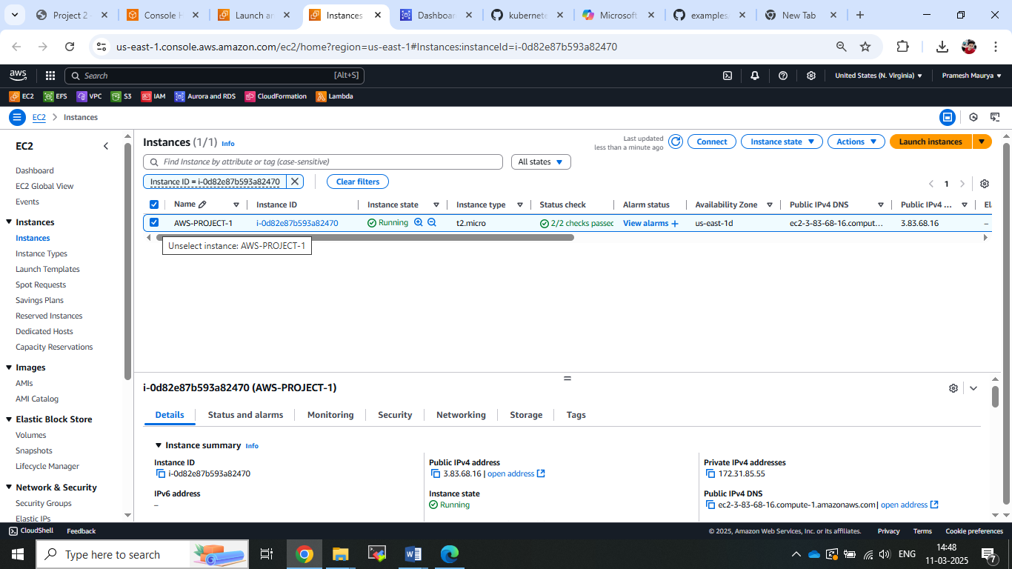

1. Launch EC2 instance with the name of AWS-Project1.
2. Now connected Ec2 instance and install apache2 server.

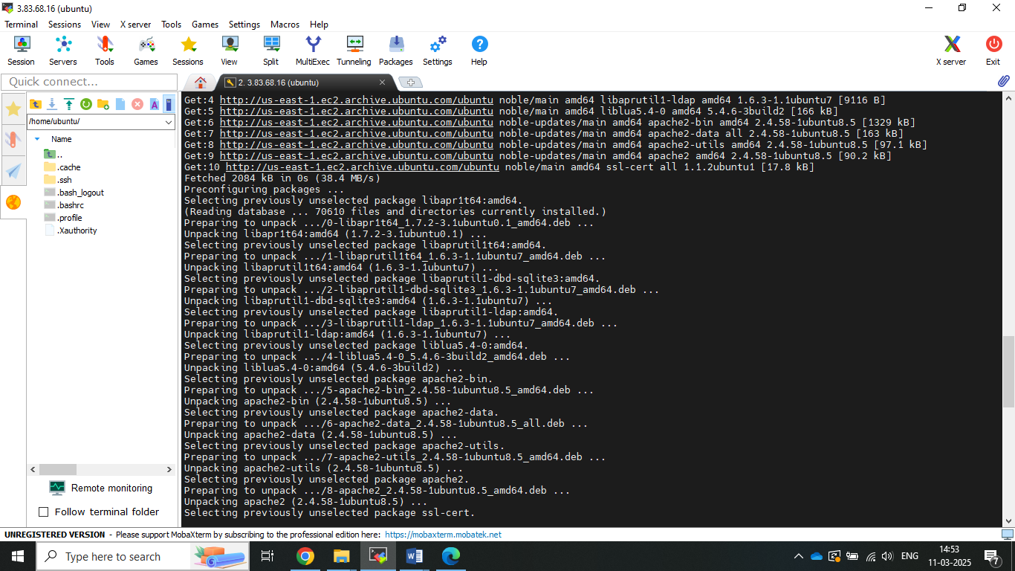

1. Command used for installed.
2. Sudo apt update
3. Sudo apt install apache2 –y.
4. **Step2 Deploy PHP Website on EC2 server.**
5. **Now** created repository on github with name of awsproject1 and upload file.

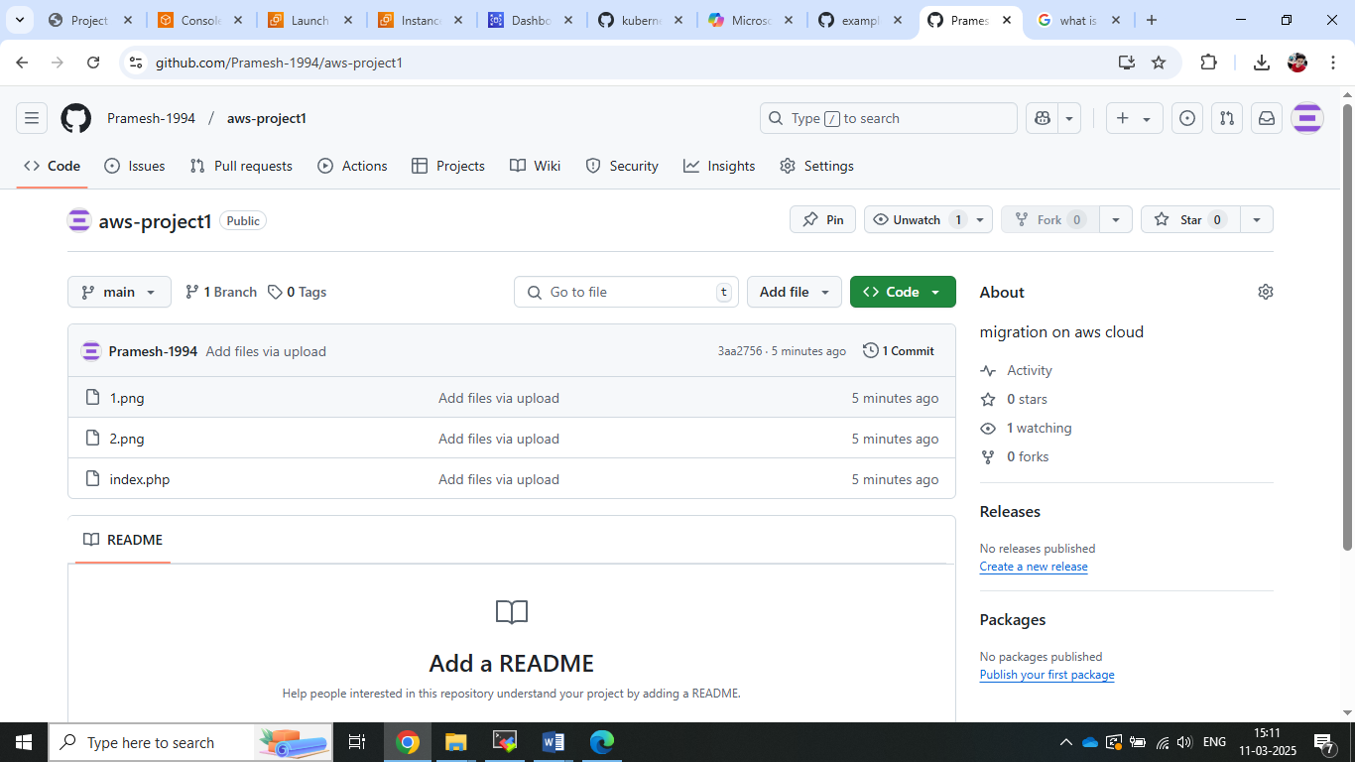

1. Now clone this repository into server.

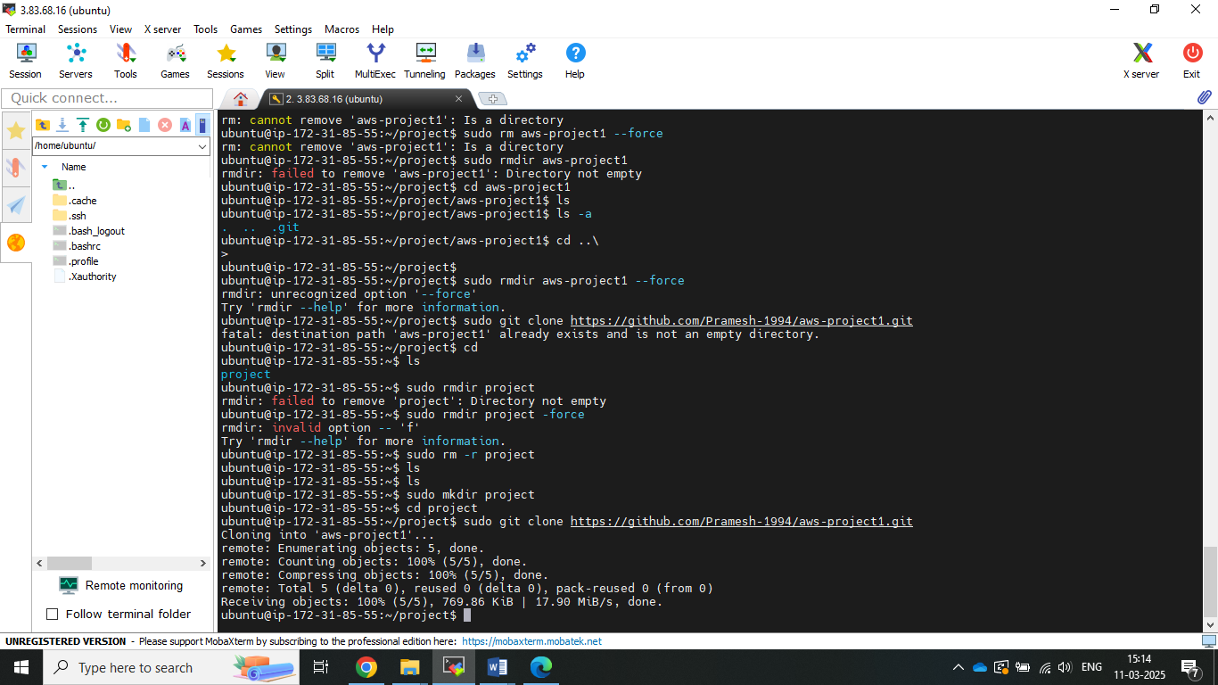

1. **Now** run the index.php file and webpage got access.

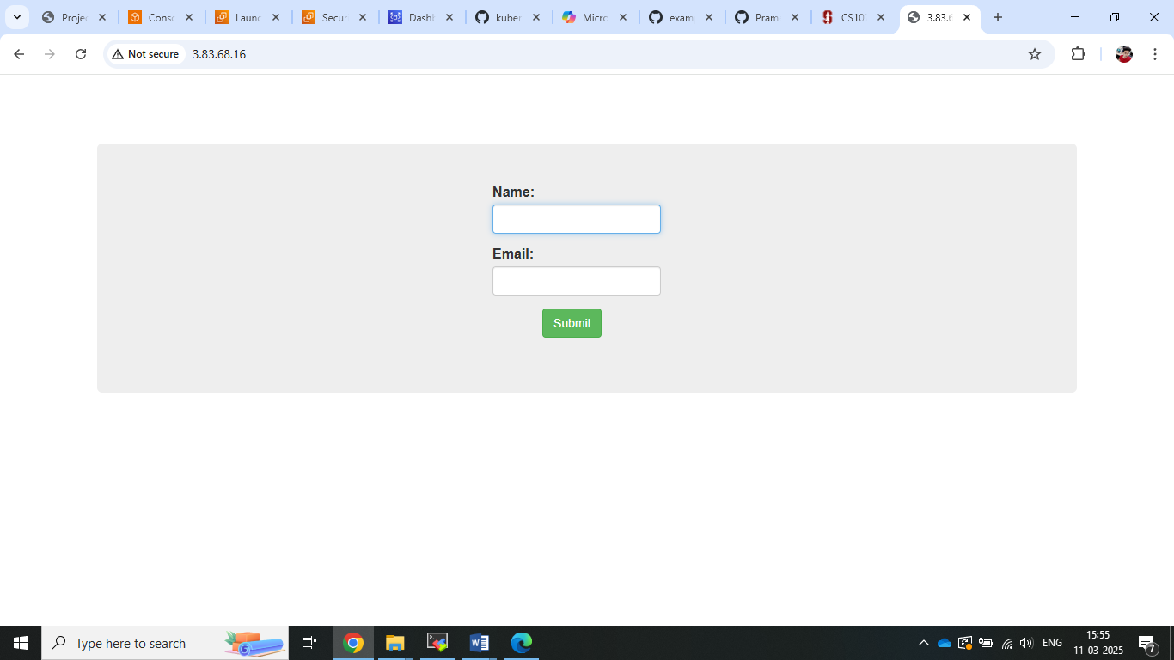

1. **Creating my sql database and connect with ec2 instance.**

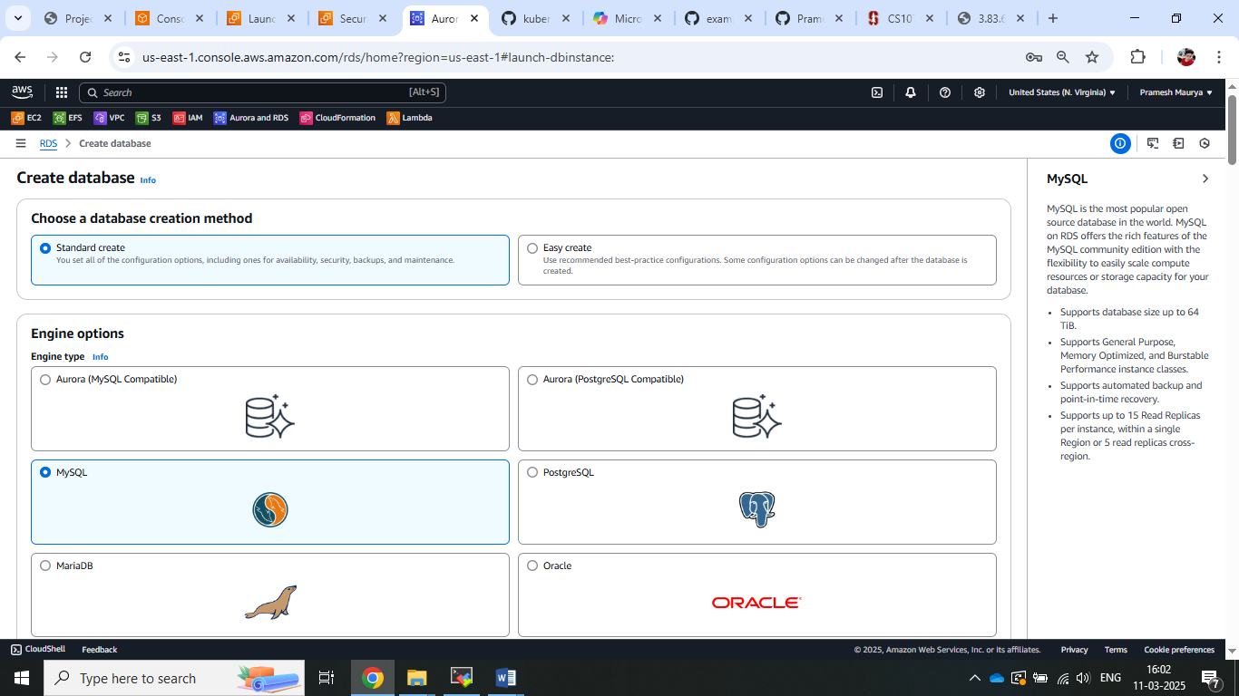

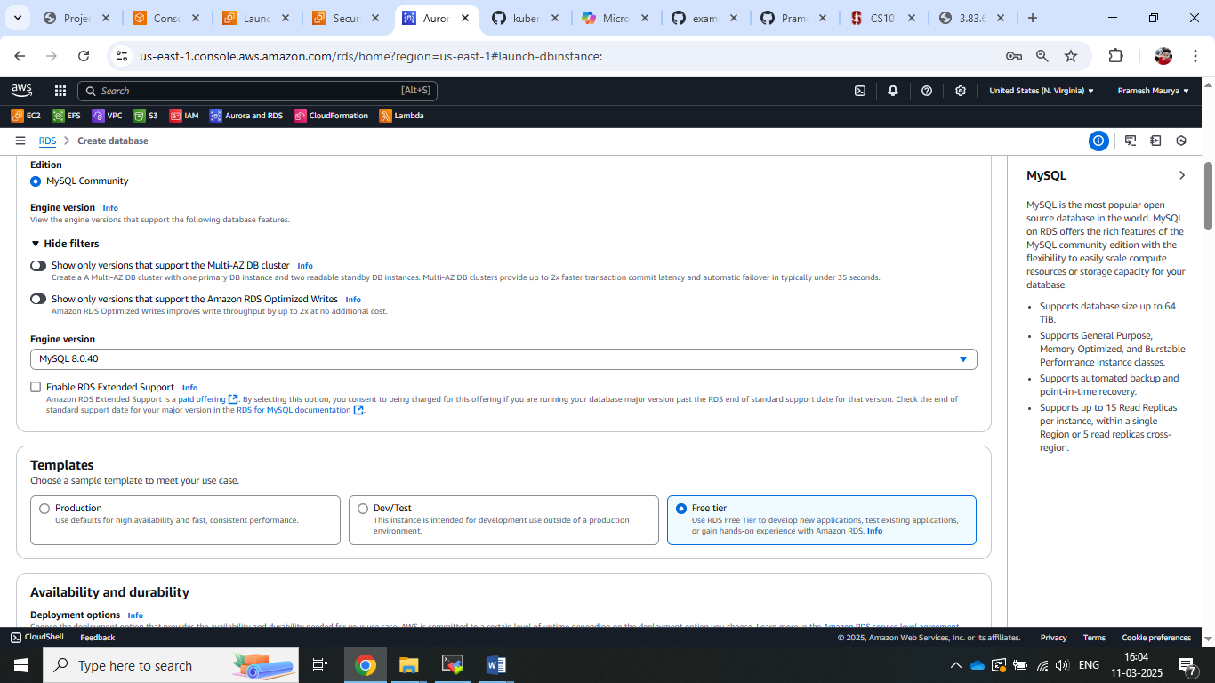

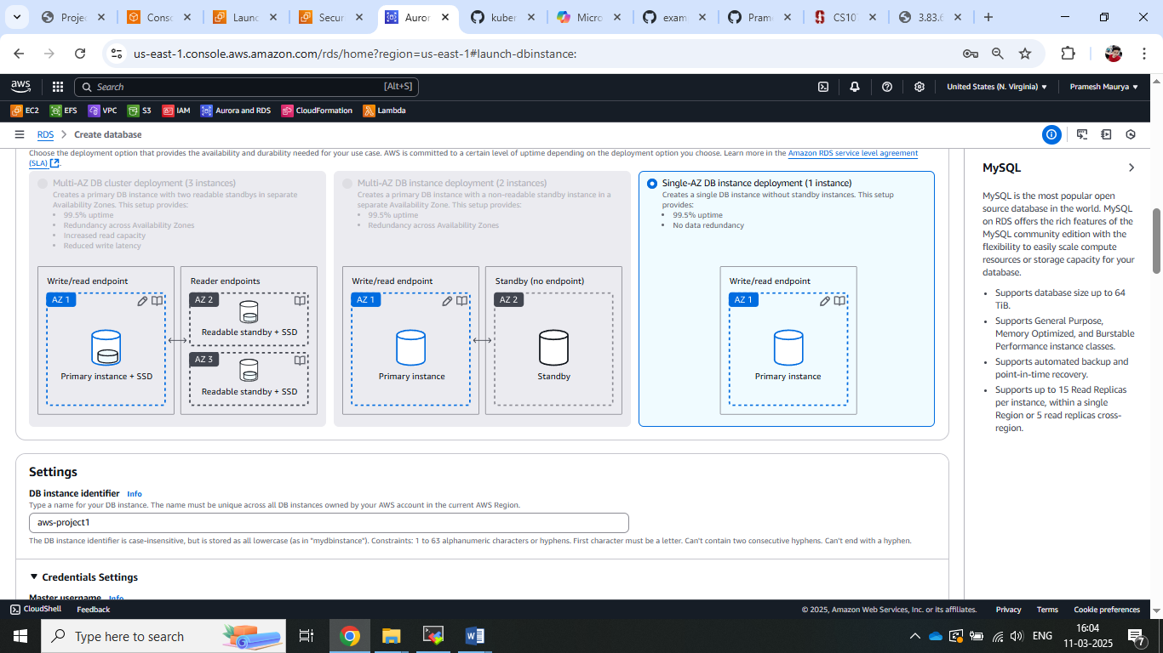

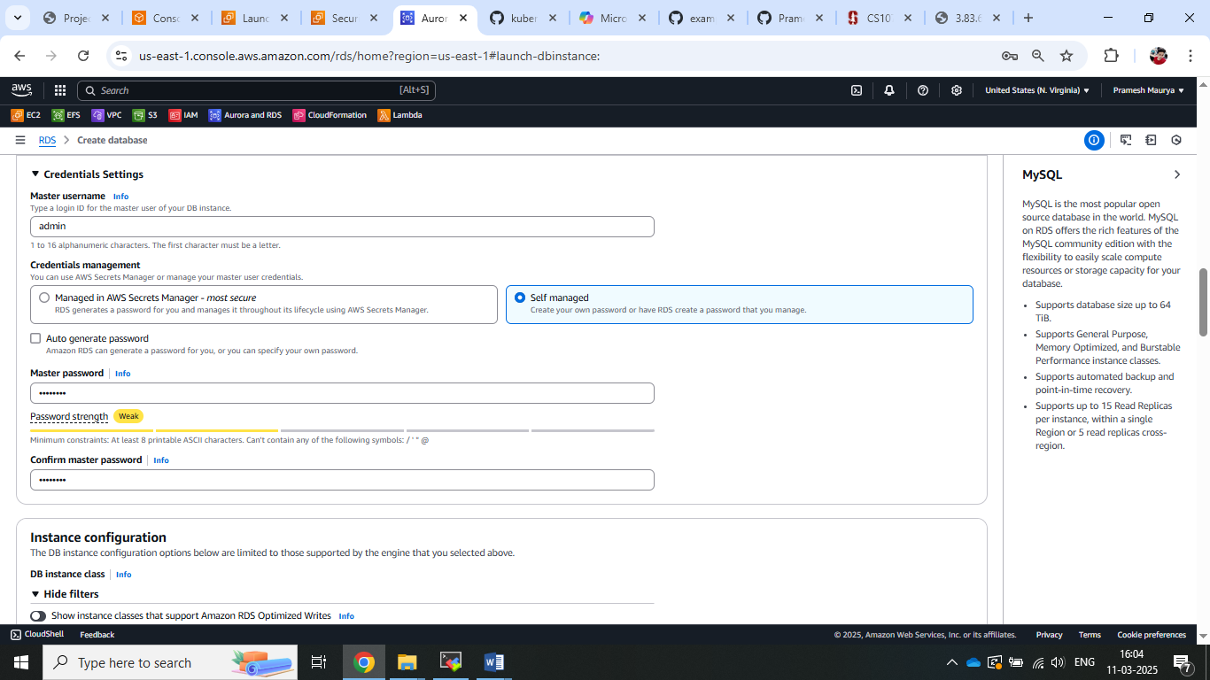

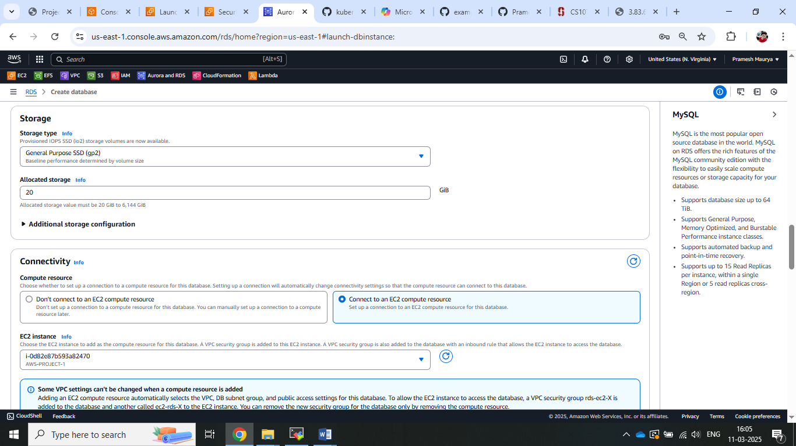

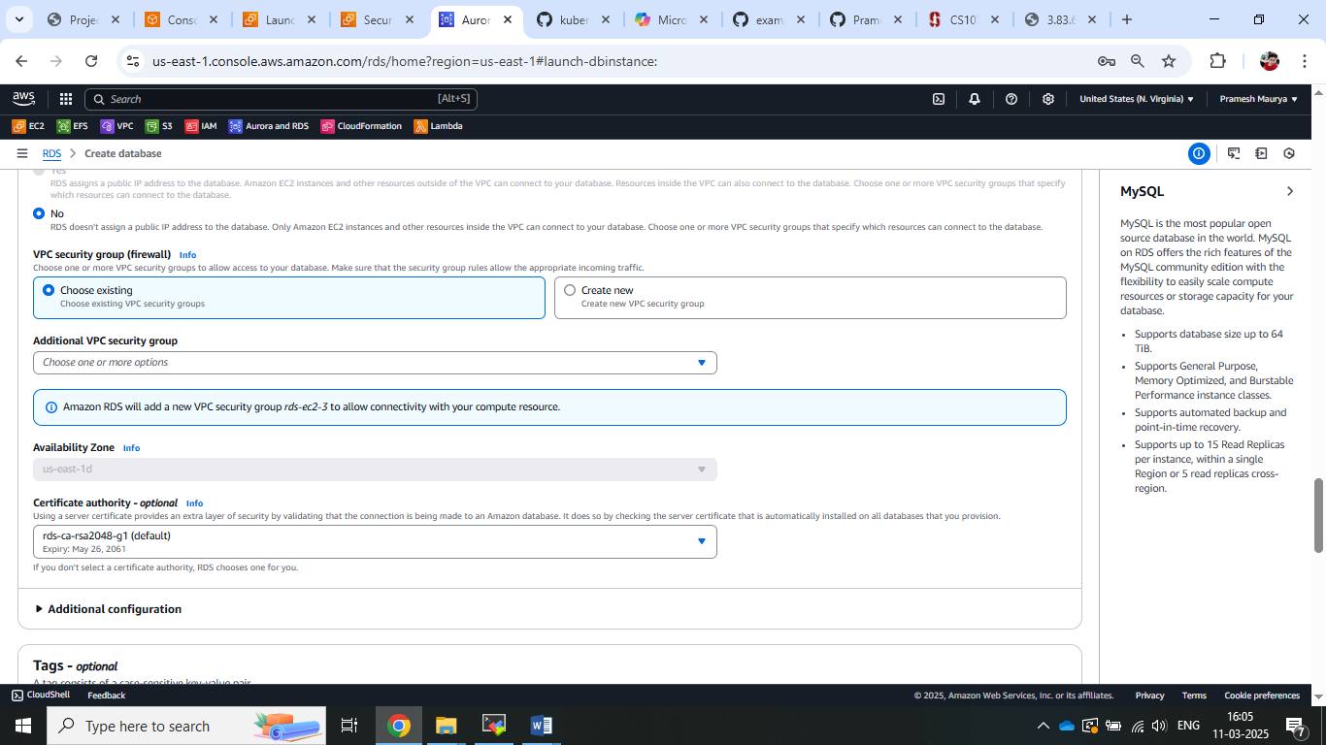

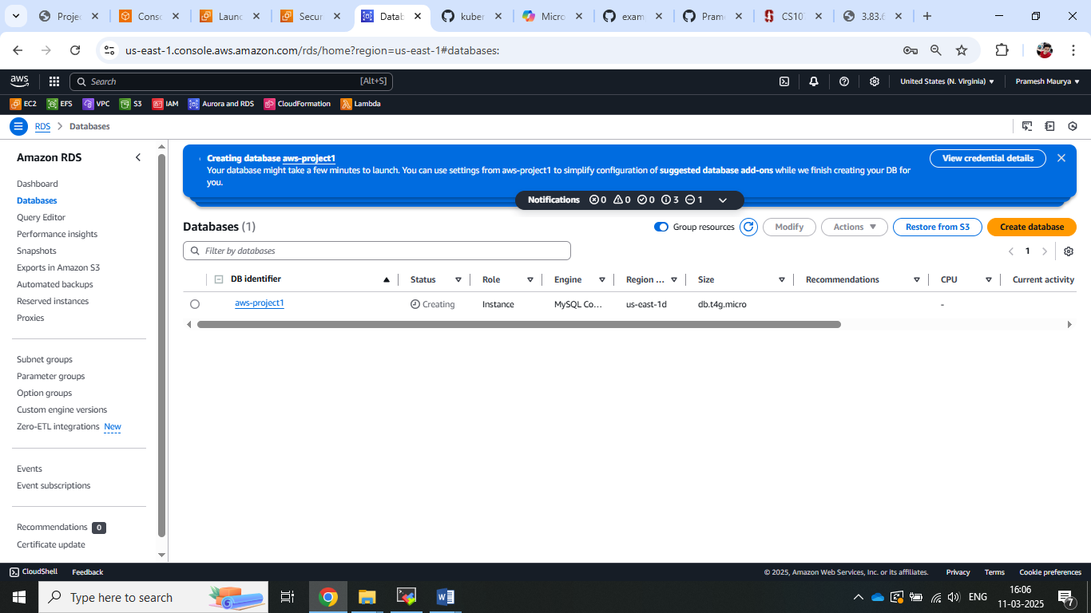

1. Now connect this RDS to EC2 and created database and table.

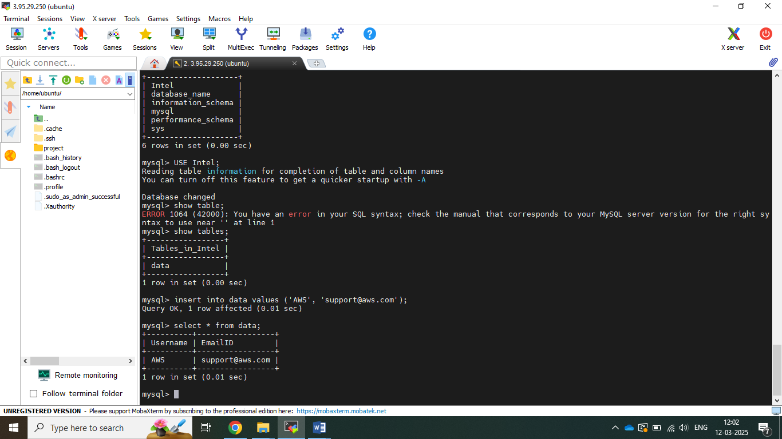

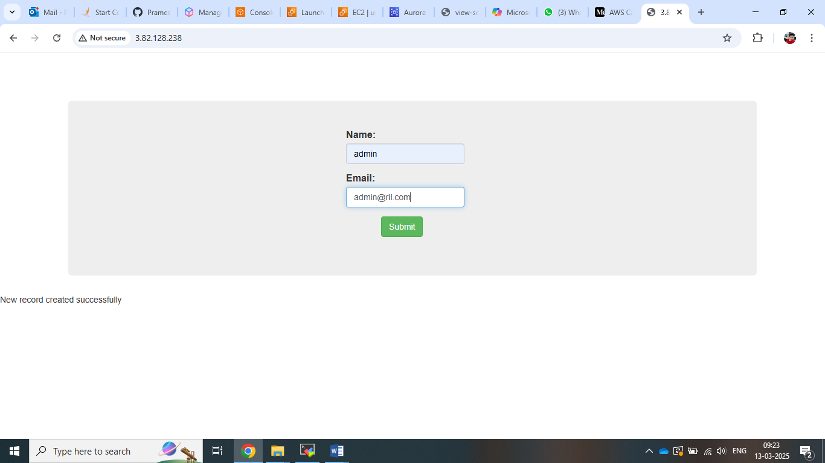

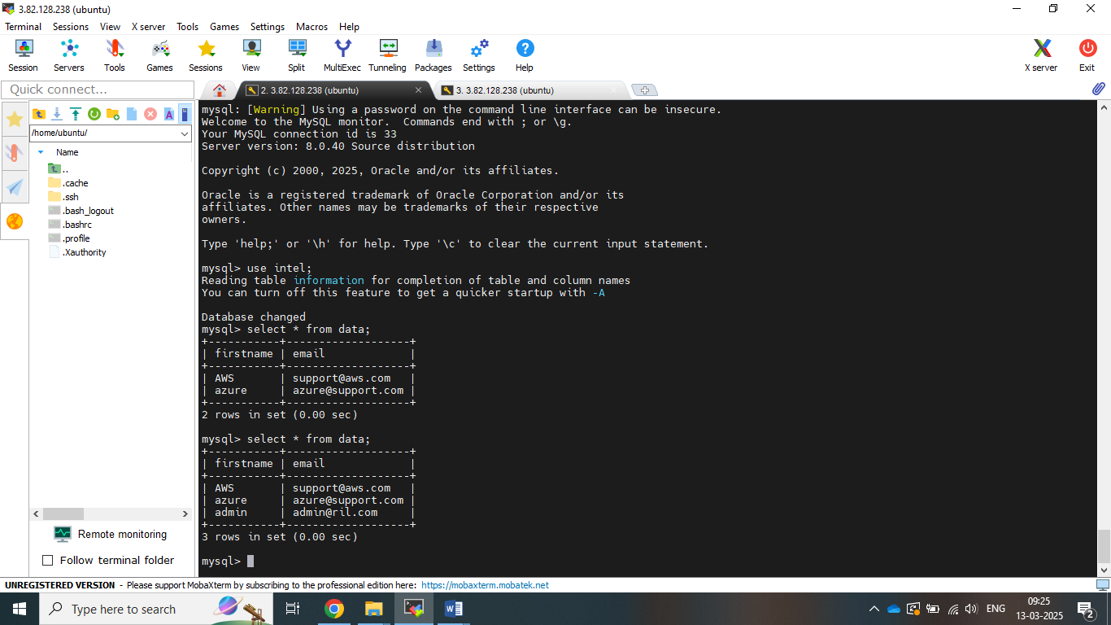

1. Now lets configure autoscaling group so step need to follow
2. Creating own ami from ec2.

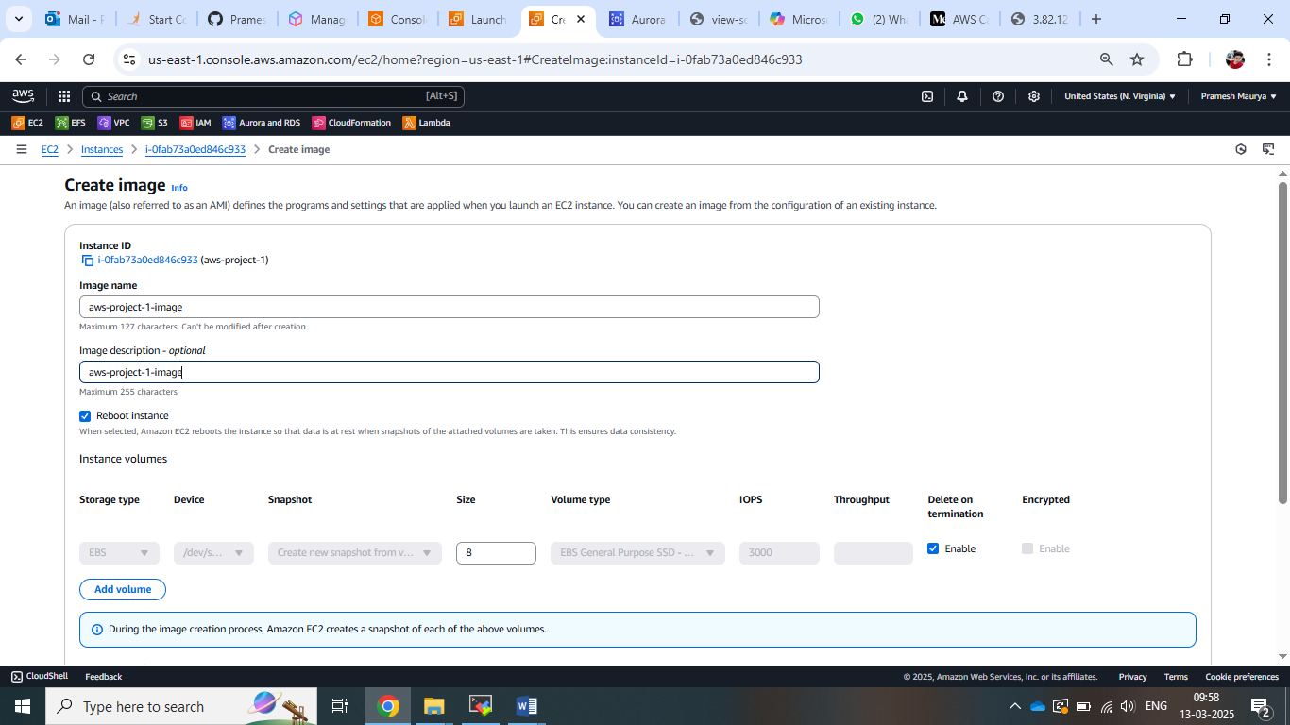

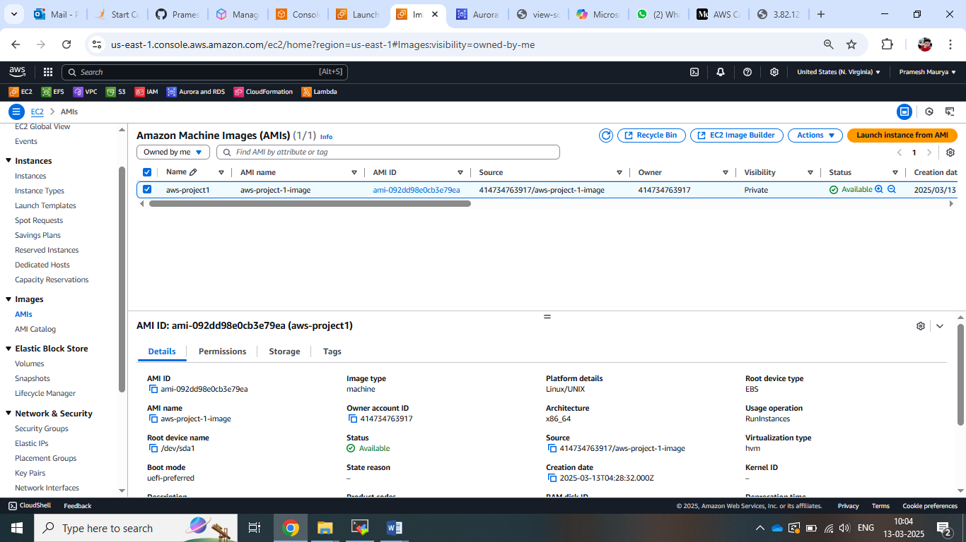

1. Now lets launch the template for autoscaling.

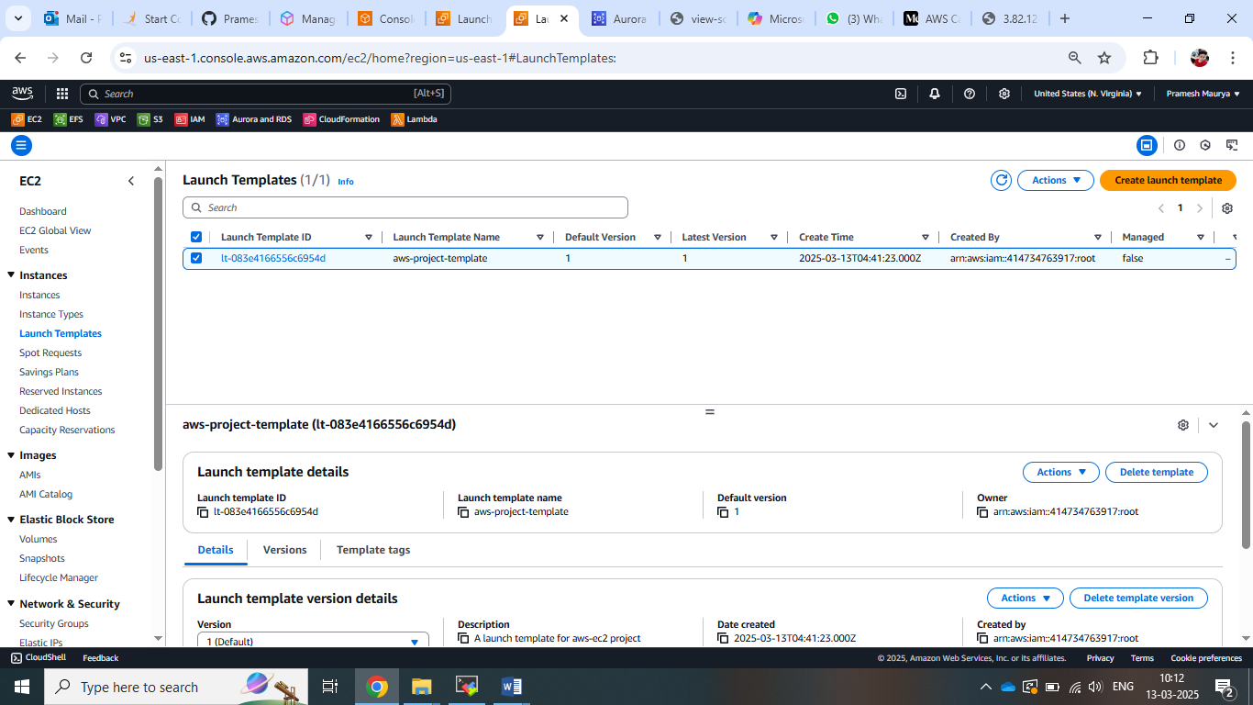

1. Now lets create autoscaling group .

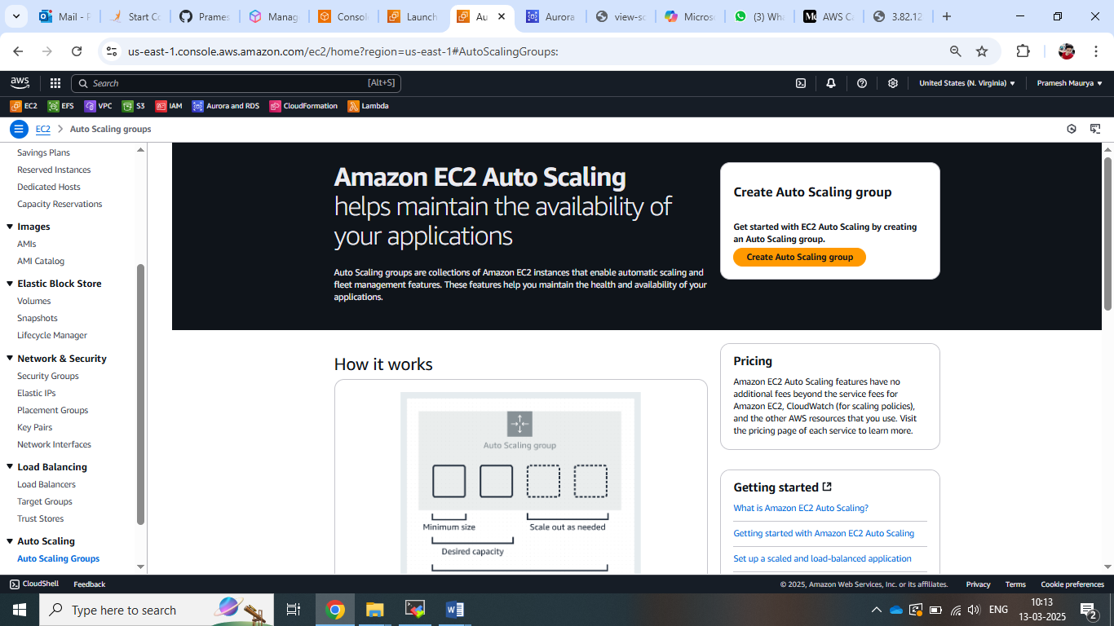

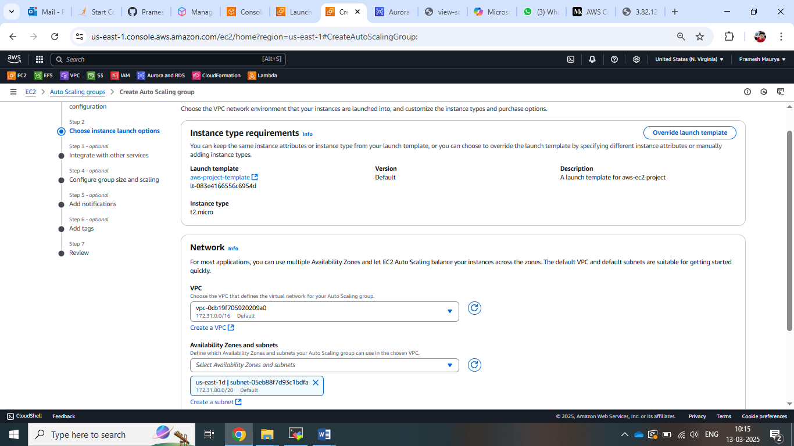

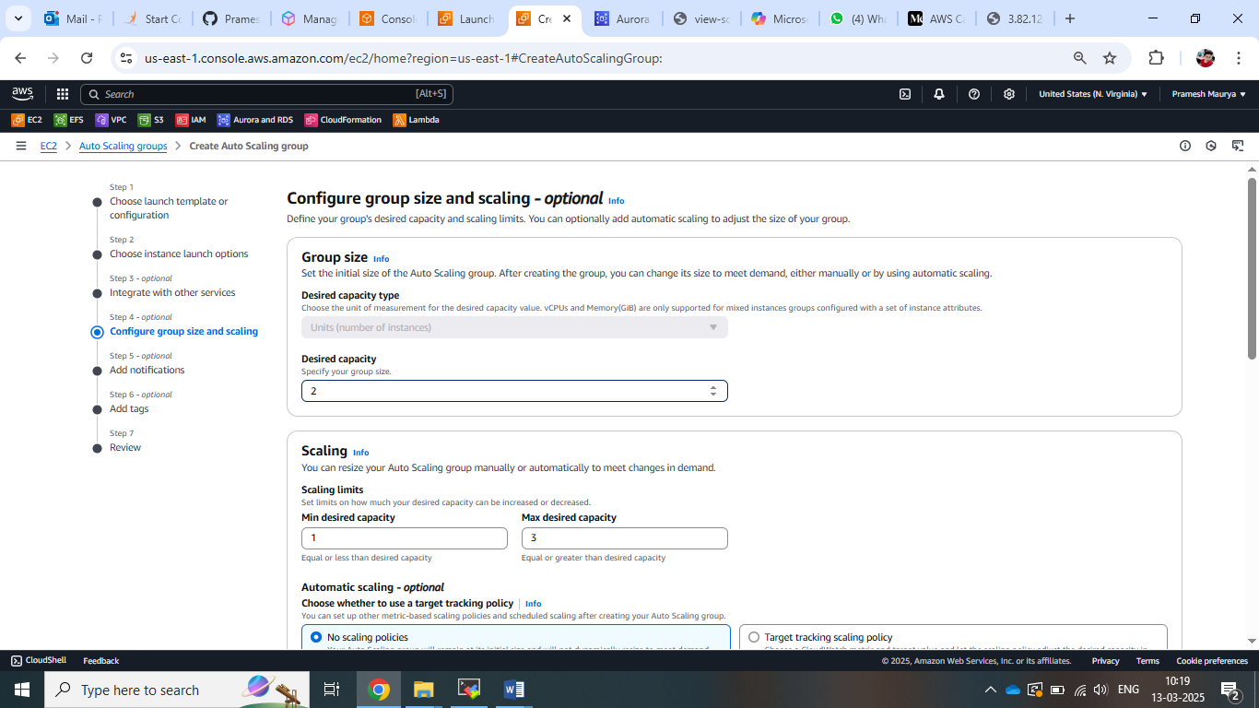

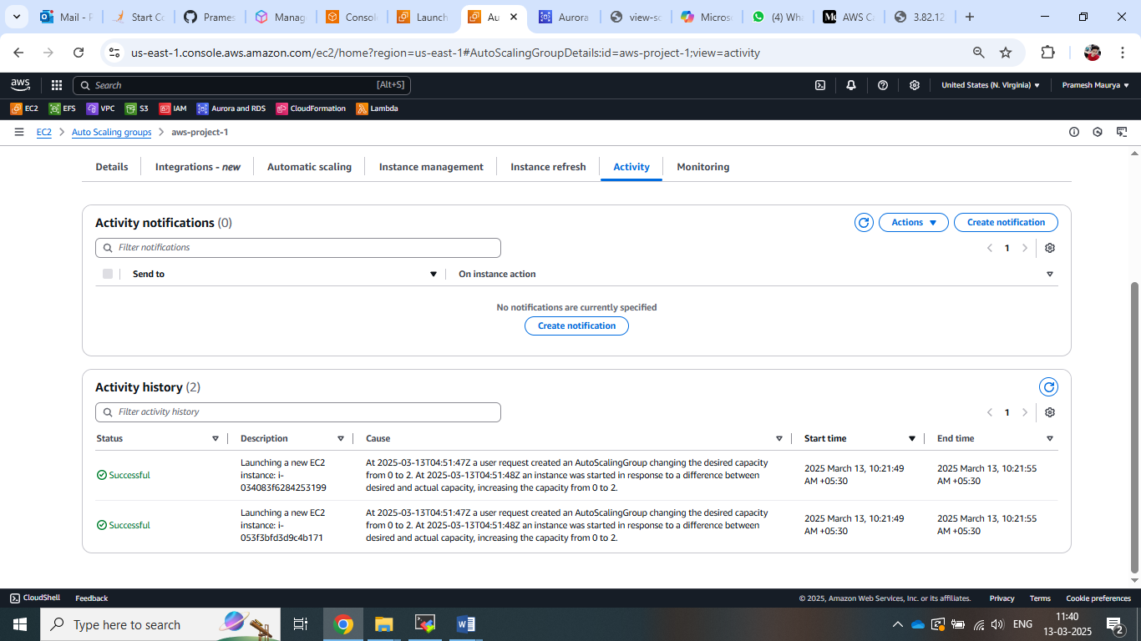

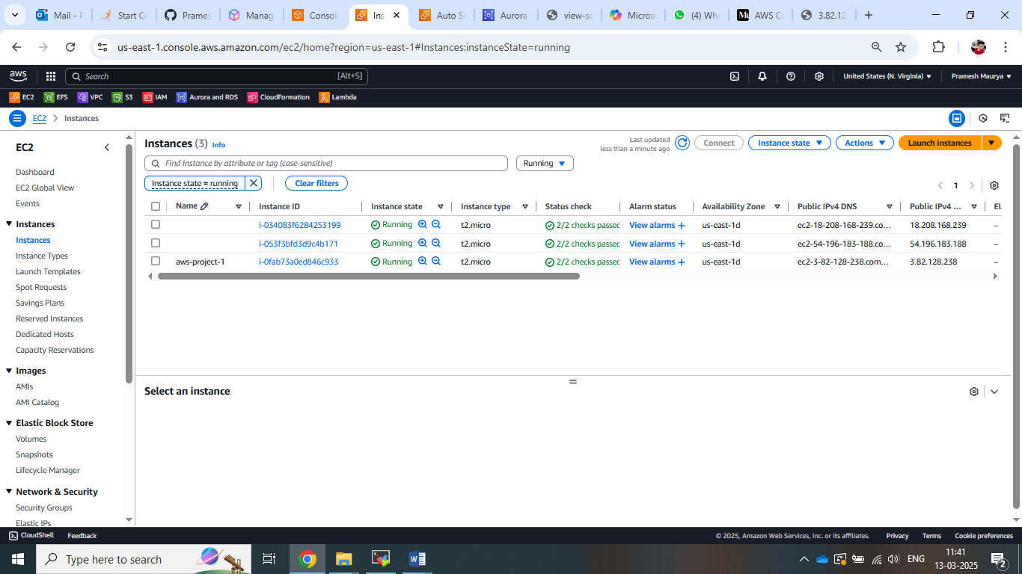

1. **Create a Target Group for Load Balancer**

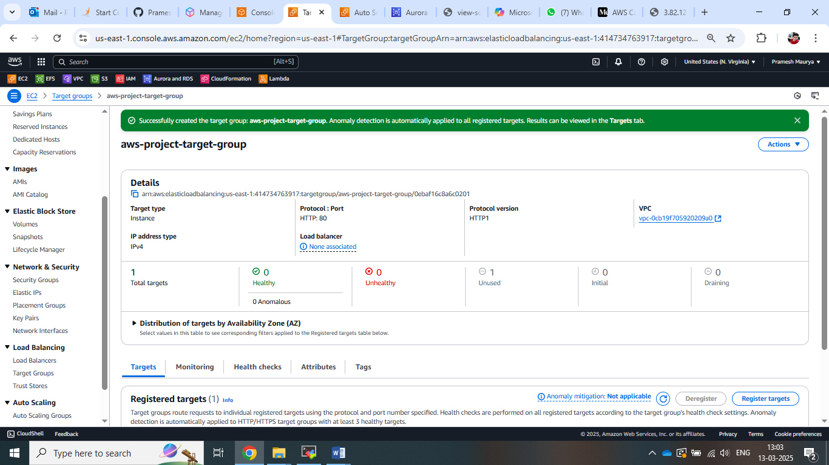

Note:- As we cant change the domain name that we don’t have free domain.

Thankyou!!